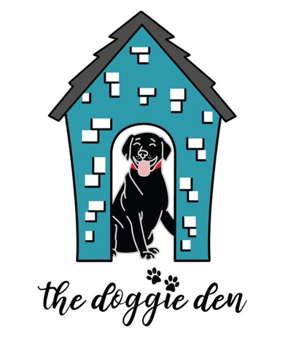
DOG BOARDING AGREEMENT

Thank you for choosing The Doggie Den for your pet boarding needs.

Requirements: All dogs must be up-to-date on all vaccines, including Bordetella, Rabies, and DHPP. Official updated vaccination records must be provided prior to entry into boarding and must be administered at least 3 days prior to either service. We reserve the right to refuse to accept a pet at check in for any reason including, without limitation, if it appears to us that the pet is sick, injured, in pain or that its behavior could jeopardize the health or safety of other pets or our staff. If your pet has a medical condition or is on any medication please see staff so they can evaluate the pet's condition.

1.) You have the option to name an adult (over the age of 18) as your agent or emergency contact. This person should not be someone who is traveling with you if you are leaving town. If we cannot reach you, you authorize us to contact your agent. You agree that your agent shall have your full and complete authority to make any and all decisions, including those related to the health of your pet and the expenditure of funds, for or on behalf of you and your pet.
2.) Emergencies: If your pet(s) becomes ill or injured in what is deemed by our employees as non-emergency, and we are unable to reach you, please indicate your wishes below:
___Please perform whatever services the doctor deems necessary for the best care of my pet until someone can be reached.
___I authorize up to $_______ to be spent on such medical services.
___Do not administer any medical services until specific authorization is given.
In cases we believe to be serious, we will take your pet to the emergency vet first before trying to contact you!
3.) Liability: You acknowledge and agree that in an unlikely event your pet is injured by another pet you release The Doggie Den and its employees from any liability for such injury. If your pet injures another pet, you will be solely responsible for any injury to the other pet (s) as well as your own pet and you release The Doggie Den and its employees from any liability for such injury. You understand that it is possible for a pet to become ill even if vaccinated. You assume all the risks and accept the responsibility of all costs for treatments. You further agree to hold the owners and employees of The Doggie Den harmless from expenses incurred for such treatment. If your pet destroys any property of The Doggie Den during his/her stay with us, you acknowledge and agree that you are responsible for charges incurred to replace such items. Page 2 of 2

4.) Payment for Services: You agree to pay us for the services we provide to your pet during each visit at the rates set forth at the start of such visit. Charges begin on the day you leave your pet. If you do not pay your bill in full at check out, The Doggie Den may retain custody of your pet, at your expense until the bill is paid in full.
5.) Personal Items: Do not bring items with your pet that are valuable or irreplaceable. The Doggie Den is not responsible for loss or damage to personal items or toys left with your pet. All medications must be in a container with a current prescription label from your veterinarian. Supplements not labeled for animals or prescribed by a veterinarian will only be given with your permission and you assume responsibility for their use.
5.) Pets not picked up on departure date/ Abandoned: If you or your agent does not pick up your pet at the agreed time you hereby authorize us to continue to provide the services as set forth in this Agreement at your expense. If the pet is deemed abandoned under local, state, or federal laws The Doggie Den will attempt to contact you by telephone and or in writing advising you that if your pet is not picked up within a reasonable time period your pet will be delivered to a third-party adoption partner, animal control, The Marion County Humane Society or other similar government agency. You understand that you may lose ownership of your pet under the circumstances. If you fail to pick up your pet for any reason you release The Doggie Den from all further liability and responsibility for your pet. You shall remain liable to us for all unpaid charges. Including the court costs and reasonable attorney's fees incurred in the collection of the charges.
6.) Miscellaneous Provision: This written agreement constitutes our entire and only agreement and there are no oral agreements or understandings except as provided for in this agreement. We reserve the right to use photographs or video footage of your pet taken during their stay. These images may be used for marketing materials, either in print form or on the internet. This agreement will remain in effect for any current or future pets you may bring to The Doggie Den until the time it may be updated.

Pet Owner: Date: ________________________________
Signed: ____________________________________________Print ___________________________

