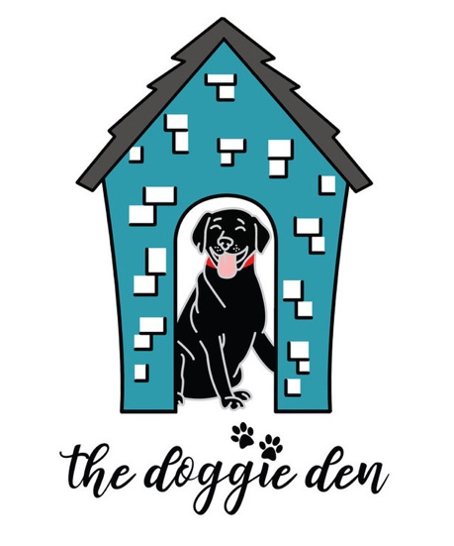

UNFORTUNATE EVENT

At The Doggie Den, we strive to provide the very best care for your pet(s) while they are at our facility. Sometimes sadly, incidents occur that are out of our control.

In the unfortunate event that your pet should pass away while in the care of The Doggie Den, your pet will be taken to our veterinarian and held at your cost until arrangements can be made.

By signing this form, you or your representative(s)____________________________________
Shall hereinafter be referred to as “Client,” and agree not to hold The Doggie Den liable for any injuries to your dog(s)____________________________________________________while in the care of The Doggie Den.

Pet Owner: Date: __________________

Signed: ___________________________________________________
Print Name_____________________________________

